-

BI
Mini Project
Walmart Analysis

Table of Contents
1 Introduction 3
1.1 Setup Checklist for Mini Project 3
1.2 Instructions 3
2 Problem Statement 4
2.1 Objective 4
2.2 Abstract of the project 4
2.3 Technology used: 4
3 Implementation in BI LOT 5
3.1 Summary of the functionality to be built: 5
3.2 Guidelines on the functionality to be built: 5

Introduction

This document outlines a mini project for the BI LOT. The project is to analyse the Walmart sales.This document contains the work flow of the system and gives guidelines on how to build the functionality gradually in each of the course modules of the BI LOT.

Setup Checklist for Mini Project
Minimum System Requirements
- Intel Pentium 90 or higher (P166 recommended)
- Microsoft Windows 2010 or above.
- Memory: 4GB of RAM (4 GB or more recommended)
- Internet Explorer 10 or higher
- Oracle 11G / SQL Server 2012 or higher
- Informatica 10.2.0 / SSIS /Data Stage / Abinitio
- Tableau Desktop / SSRS / PowerBi / Qlickview

Instructions
- The code modules in the mini project should follow all the coding standards.
- Create a directory by your name in drive <drive>. In this directory, create a subdirectory MiniProject. Store your Project here.
- You can refer to your course material.
- You may also look up the help provided in the BI docs and documentation provided in respective tools.

Problem Statement

Objective
To analyse the sales of Walmart.

Abstract of the project
It is provided with historical sales data for 45 Walmart stores located in different regions. Each store contains many departments, and participants must project the sales for each department in each store. To add to the challenge, selected holiday markdown events are included in the dataset..

Technology used:
- Oracle 11G / SQL server (Database)
- Informatica power center / SSIS / DataStage / Abinitio(ETL Tool)
- Tableau Desktop / SSRS / PowerBI/ Qlickview (Reporting Tool)

Implementation in BI LOT

Summary of the functionality to be built:
The participants need to develop the Walmart analysis by building the functionality incrementally in each of the course modules of BI LOT using one of the above ETL and reporting tool .

Guidelines on the functionality to be built:
Project flow

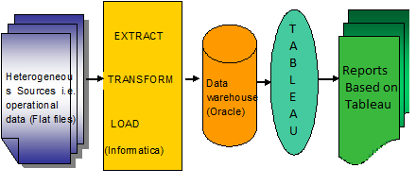

Dimension model:

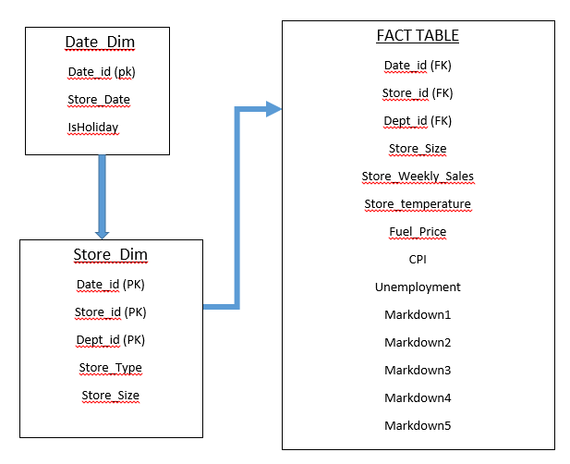

Schema Design :

The project follows the star schema approach.
- The Dimension tables are :
- Walmart_date_dim
- Walmart_store_dim

- The Fact Table is :
- Walmart_fact_table

Walmart_store_dim
Date_id (PK) | int
Store_id (PK) | Int
Dept_id (PK) | Int
Store_type | Varchar
Store_date | Date
Store_size | Int

Walmart_date_dim
Date_id (PK) | Int
Store_Date | Date
Isholiday | varchar

Walmart_fact_table
Date_id (FK) | Int
Store_id (FK) | Int
Dept_id (FK) | Int
Store_size | Number
Store_Weekly_sales | Decimal
Fuel_price | Decimal
Store_temperature | Decimal
Unemployement | Decimal
CPI | Decimal
Markdown1 | Decimal
Markdown2 | Decimal
Markdown3 | Decimal
Markdown4 | Decimal
Markdown5 | Decimal

Note: The datatype/length for the Dimension/Fact table attribues can be changed as required. Additional fields can be added, if required.

The Dimensions are Walmart_date_dim , Walmart_store_dim.
- Walmart_date_dim:

This dimension contains date of each store.
- Date_Id (PK)
- Date
- Isholiday

- Walmart_store_dim:

This dimension contains about store details.
- Date_id (PK)
- Store_id (PK)
- Dept_id (PK)
- Store_type
- Store_date
- Store_size

- Walmart_fact_table:

This is a Fact table that contains foreign keys and measures.
- Date_id (FK)
- Store_id (FK)
- Dept_id (FK)
- Store_size
- Store_weekly_sales
- Fuel_price
- Temperature
- unemployement
- CPI
- Markdown1
- Markdown2
- Markdown3
- Markdown4
- Markdown5

Sample Reports:

